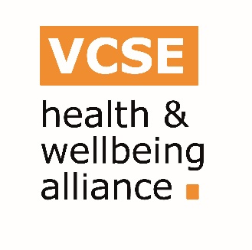
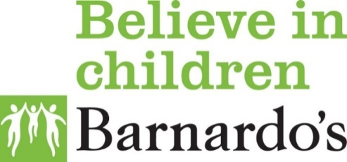
Health and Wellbeing Alliance
Examples of practice - Whole Family Approaches

Name:
Organisation:

Please provide as much detail as possible for us to develop your organisational case study for delivering culturally sensitive family support work.

As an organisation:
- How do you reach the families who access your services or how do they come to you?

(For example, please think about: How do you do it? How do you go over and above to engage people? Or how do you do things differently to the more ‘traditional’ statutory services?)

Why does this approach work for your organisation to reach and engage children and families in the services you offer?

(For example: what is the one thing that really engages parents that would recommend to similar organisations struggling to reach out)

- Please tell us about one specific family intervention (way of working with a family and CYP) that supports both the family and the CYP to engage in other activities and or improves outcomes? (I.e. Accessing health services, reducing isolation/increasing social support, healthy child development, mental health, diet, healthy activities)

- What skills and qualities do workers need to have when working in your community? Think about the skills/qualities that build trust, remove stigma and enable families to open up. Think about those skills/qualities we might miss off on a job description but they are the critical success factors.

- From your experience, how can culturally sensitive approaches to family support be developed? What resources and tools do you use with families?

- What learning would you want to share from your work with the NHS about the communities you work with?

