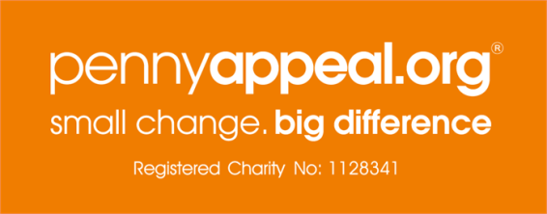



Participant Consent Form

Investigating domestic abuse within Muslim Communities across the UK

In signing this consent form I confirm that:

I have read the Participant Information Sheet and the nature and purpose of the research project has been explained to me. | Yes |  | No
I have had the opportunity to ask questions. | Yes |  | No
I understand the purpose of the research project and my involvement in it. | Yes |  | No
I understand that my participation is voluntary and I may withdraw from the research project at any stage, without having to give any reason and withdrawing will not penalise or disadvantaged me in any way. | Yes |  | No
I understand that while information gained during the study may be published, any information I provide is confidential (with one exception – see below), and that no information that could lead to the identification of any individual will be disclosed in any reports on the project, or to any other party. No identifiable personal data will be published. | Yes |  | No
I understand that the researcher may be required to report to the authorities any significant harm to a child/young person (up to the age of 18 years) that he/she becomes aware of during the research. I agree that such harm may violate the principle of confidentiality. | Yes |  | No
I agree that extracts from the interview may be anonymously quoted in any report or publication arising from the research [Omit if quotes not being used] | Yes |  | No
I understand that the interview will be recorded using audiotape/electronic voice recorder/video recorder [Amend/delete as applicable] | Yes |  | No
I understand that data will be securely stored | Yes |  | No
I understand that I may contact the researcher if I require further information about the research, or if I wish to make a complaint relating to my involvement in the research. | Yes |  | No
I agree to take part in the above research project. | Yes |  | No

Participant’s name (BLOCK CAPITAL) |  | Participant’s signature |  | Date

Researcher’s name (BLOCK CAPITAL) |  | Researcher’s signature |  | Date

[Include following if third party/independent witnesses required]

Third party’s name (BLOCK CAPITAL) |  | Third party’s signature |  | Date

