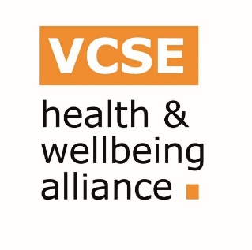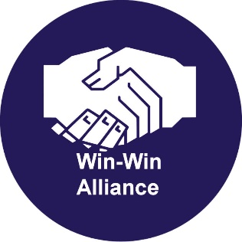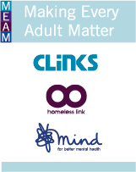

CALL FOR EVIDENCE: Supporting inclusive workplaces for everyone – Health Related Pathways to Work

Background

Homeless Link and Win/Win Alliance are co-leading a Health and Wellbeing Alliance project involving eight other Alliance members as well as the Employment Related services Association (ERSA), and Making Every Adult Matter (MEAM). The partnership is supporting the Health and Work Unit to work towards inclusive workplaces for everyone. Funded by Public Health England (PHE), the project will produce resources to help employers to embed good practice approaches supporting disabled people, people with long term health conditions and/or people from protected characteristic groups towards, into and to stay in work.

Central to this work is developing an Employer Directory to highlight ‘national and local pathways to work’. This electronic Directory of employment support programmes will sit alongside a Pathways to Work toolkit for public sector employers and the voluntary and community sector.

These resources will help employers work with and support disabled people, people with long term health conditions and disabilities and people with protected characteristics as defined by the Equalities Act 2010: age; disability; gender reassignment; marriage and civil partnership; pregnancy and maternity; race; religion or belief; sex; sexual orientation. The work will also seek to address the needs of homeless people, those with experience of poor mental health, people in contact with the criminal justice system and people with experience of substance misuse.

As part of this project we are issuing a Call for Evidence for examples of national and local employment support initiatives and “success stories” helping people towards, into and to stay in work. The good practice and success stories will be brought together as a Directory that will be shared with employers.

This project will include a toolkit which supports employers to implement a psychologically informed approach - a framework for working with people who have experienced repeated adverse life events. We are particularly interested in organisations which use reflective practice and/or an understanding of the impact trauma can have on a person’s emotions and behaviour.

How to respond

Please share any examples of work being undertaken currently or previously, using the template at the end of the document. These examples will be used to identify and highlight effective practice and inform employers about employment support programmes.

If you are engaged in multiple projects supporting any of these groups, please complete a separate template for each activity. If the information for any of the sections is not available, please leave them blank.

Please return any examples to policy@ersa.org.uk by Friday 19 October 2018.

If you have any questions about the research, please contact Michaela.DesForges@homelesslink.org.uk

SUPPORTING INCLUSIVE WORKPLACES FOR EVERYONE: CALL FOR EVIDENCE TEMPLATE
Name of your organisation

Name of your project, programme or initiative
Date intervention started (and ended if applicable)

Summary: please tell us about your intervention  (please ensure any information about work with individuals is given on the basis that the individuals concerned remain anonymous and no identifiable personal information is given) | Aims:  Activities delivered:  Who delivers it:  Where it is delivered:
Target characteristics and/or client group(s) (please delete as appropriate). | - Age (Older people)  - Age (Younger people)  - Disability  - Gender reassignment  - Marriage and civil partnership  - Pregnancy and maternity  - Race  - Religion or belief  - Gender  - Sexual orientation  - Homelessness  - Mental health conditions  - People in contact with the criminal justice system  - Substance misuse
Partner organisations – who else is involved in designing and/or delivering it?

How is it funded?

How much does it cost to deliver (if applicable)?

Outcomes: what are the outcomes for the intervention and how are they measured?

Has it been evaluated? Please provide any further evidence of impact and the methodology used. Or please provide the evaluation report if this is available.

What has been key to the intervention’s success and outcomes?

Were there any barriers to implementation? What lessons have you learned from implementation?

Can this case study be included in our final materials?

If yes, please also provide contact details to be included in the online directory (website address / email / phone number)

Is there anything else about the intervention you think would be useful to share with us?

Please provide case studies and images of individuals you have supported through your intervention (with media consent, in order to publish in the online Directory)

Please provide employer testimonials and images (with media consent, in order to publish in the online Directory)

Thank you for completing this call for evidence.

