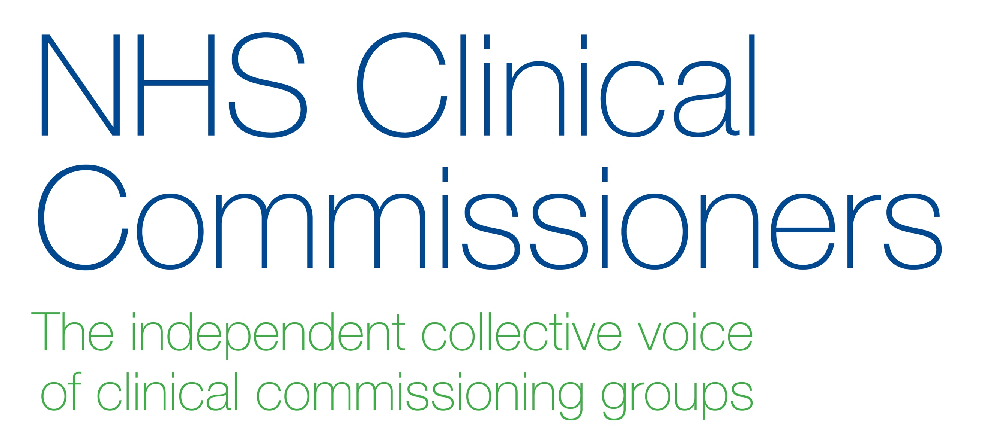

29 March 2018

Dear colleague

Thank you to everyone who responded to the public consultation on the prescribing of over the counter medicines (medicines which don’t need a prescription or a visit to a GP) which ran from December 2017 to March 2018.

Today NHS England has published the final guidance for CCGs and we are writing to highlight the plan for implementation this year.

What has changed?
The guidance has been reviewed by the joint NHS England and NHS Clinical Commissioners clinical working group reflecting feedback from the consultation. The guidance covers 35 minor health conditions which are either ‘self-limiting’ or suitable for ‘self-care’. The new guidance recommends that, for these 35 minor conditions, medicines which are available over the counter should no longer be routinely prescribed. Vitamins, minerals and probiotics are also included in the restrictions as items of limited clinical effectiveness.

- A self-limiting condition does not require any medical advice or treatment as it will clear up on its own, such as sore throats, coughs, colds and viruses.

- A minor illness that is suitable for self-care can be treated with items that can be purchased over the counter from a pharmacy. These conditions include, for example, indigestion, mouth ulcers, and warts and verrucae.
When will the changes happen?
The commissioning guidance is addressed to CCGs and should now be considered by individual CCG boards which will determine the timescale for decision and implementation in their local areas during 2018. A range of national resources will be developed to support local implementation.

Who is affected?
Once CCGs have adopted the new guidance locally, it will apply to everyone who is not covered by the general or condition-specific exceptions listed in the guidance document. In relation to the exceptions, it is important to highlight:
- The guidance does not apply to people with long-term or more complex conditions who will continue to get their usual prescriptions.
- People who receive free prescriptions will not automatically be exempt from the guidance.
- For patients where the clinician considers that their ability to self-manage is compromised as a consequence of medical, mental health or significant social vulnerability; these patients will continue to receive prescriptions for over the counter items subject to the item being clinically effective.
- For the self-limiting conditions, where symptom relief may be required, the general exceptions will only apply where the prescription is for an over the counter item that is clinically effective.​
- For vitamins, minerals and probiotics, only the condition-specific exceptions will apply.
The new guidance supports the NHS’s wider ambition to ensure greater value from the annual £17.4 billion medicines bill, through reducing waste, over-prescribing and over-treatment.

The intention is to implement a consistent, national framework for CCGs, and reduce variation, while taking account of local circumstances and the legal duties of CCGs to advance equality and have regard to reducing health inequalities.

The new guidance also supports the aim of the NHS to promote self-care where possible for minor conditions, and highlight the alternatives to making a GP appointment or taking a medicine. For further information on self-care please visit NHS Choices

Kind regards

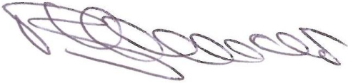
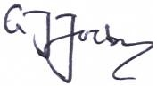

Dr Bruce Warner Dr Graham Jackson
Deputy Chief Pharmaceutical Officer Co-Chair
NHS England NHS Clinical Commissioners

